Cross-quantilogram: NZDUSD and USDCHF
Method 20 / daily log returns / expanding quantiles / Alpari D1 full available history

Study setup
Logical pair: NZDUSD , USDCHF
Broker symbols: NZDUSD_i , USDCHF_i
Snapshot: 2026-11-03_majors_alpari_D1
Timeframe: D1
Matched return window: 1999-01-05 to 2026-11-02 (UTC bar dates)
Matched return count n: 7185
Dropped unfinished last bar dated 2026-11-03 UTC after a tick-volume check against the prior complete day.
Quantiles: expanding window, min history 252 days
tau in [0.05, 0.2]; k=0..10; headline tau=0.05, k=1
Complete matched rows (Excel): NZDUSD-USDCHF_CQ_D1.xlsx
Complete matched rows (HTML table): NZDUSD-USDCHF_CQ_D1_data.html

Method carried forward
The cross-quantilogram rho_tau(k) measures linkage among centered quantile-hit indicators of matched daily log returns of close, ln(close_t / close_t-1). Quotes are not inverted. At each date t, the tau-quantile uses only returns through t (expanding window) after a minimum history of 252 days. Hits are h_t = 1(r_t < q_t) - tau. rho_tau(k) is the normalized cross-product of h_x,t with h_y,t+k. Levels tau in {0.05, 0.20} and lags k=0..10 are pre-specified; headline is tau=0.05, k=1 both directions. Same-sample Pearson r is a side check. This is not causation and not a trading signal.

Results (headline)
rho_NZDUSD->USDCHF(tau=0.05,k=1): 0.016576
rho_USDCHF->NZDUSD(tau=0.05,k=1): 0.020447
rho_NZDUSD->USDCHF(tau=0.20,k=1): 0.017039
rho_USDCHF->NZDUSD(tau=0.20,k=1): 0.010503
Pearson r: -0.393600

CQ table (tau=0.05)
k | rho_NZDUSD_to_USDCHF | n_NZDUSD_to_USDCHF | rho_USDCHF_to_NZDUSD | n_USDCHF_to_NZDUSD
0 | -0.01437969 | 6934 | -0.01437969 | 6934
1 | 0.01657648 | 6933 | 0.02044722 | 6933
2 | 0.0320501 | 6932 | 0.02817932 | 6932
3 | 0.02429909 | 6931 | 0.06687814 | 6931
4 | 0.02428965 | 6930 | 0.03590223 | 6930
5 | 0.02040931 | 6929 | 0.0436347 | 6929
6 | 0.01675596 | 6928 | 0.02039984 | 6928
7 | 0.02838262 | 6927 | 0.02813231 | 6927
8 | 0.06328213 | 6926 | 0.059091 | 6926
9 | 0.04000021 | 6925 | 0.0358556 | 6925
10 | 0.04386975 | 6924 | 0.04745954 | 6924

Conclusion
Headline tau=0.05, k=1 for NZDUSD and USDCHF: rho_NZDUSD->USDCHF = 0.0166; rho_USDCHF->NZDUSD = 0.0204. At tau=0.20, k=1: 0.0170 and 0.0105. Same-day tau=0.05 rho(k=0) = -0.0144. Pearson r = -0.3936. This is quantile-hit linkage, not a trading signal.

Charts
Daily closes

Daily log returns

Cross-quantilogram tau=0.05
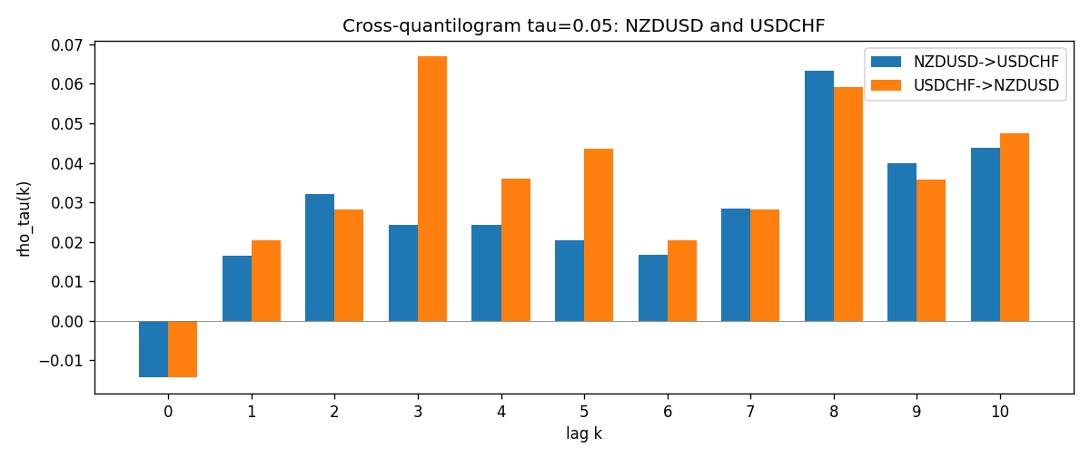

Data report
Matched rows and the CQ sheet are in the sibling Excel workbook named NZDUSD-USDCHF_CQ_D1.xlsx. Embedding all rows as a Word table is impractical; this file holds column summaries and the first and last 15 matched rows.
Columns: time, NZDUSD_open, USDCHF_open, NZDUSD_high, USDCHF_high, NZDUSD_low, USDCHF_low, NZDUSD_close, USDCHF_close, NZDUSD_tick_volume, USDCHF_tick_volume, NZDUSD_spread, USDCHF_spread, NZDUSD_real_volume, USDCHF_real_volume, NZDUSD_log_return, USDCHF_log_return, NZDUSD_h_t005, USDCHF_h_t005
Column summaries (matched calculation rows)
column | count | mean | std | min | 25% | 50% | 75% | max
NZDUSD_open | 7185 | 0.65641395 | 0.10821881 | 0.3913 | 0.59137 | 0.6684 | 0.72499 | 0.88218
USDCHF_open | 7185 | 1.0976269 | 0.25248305 | 0.72022 | 0.92053 | 0.98988 | 1.2378 | 1.8219
NZDUSD_high | 7185 | 0.66033247 | 0.10871106 | 0.3961 | 0.59478 | 0.672 | 0.72937 | 0.88421
USDCHF_high | 7185 | 1.1029176 | 0.25422469 | 0.73305 | 0.92474 | 0.99353 | 1.2423 | 1.8313
NZDUSD_low | 7185 | 0.65272894 | 0.10781325 | 0.3897 | 0.58811 | 0.66417 | 0.72099 | 0.87988
USDCHF_low | 7185 | 1.0925083 | 0.25089773 | 0.08565 | 0.91719 | 0.98622 | 1.2317 | 1.8121
NZDUSD_close | 7185 | 0.65649284 | 0.10821292 | 0.3907 | 0.59165 | 0.6684 | 0.72502 | 0.8822
USDCHF_close | 7185 | 1.0976163 | 0.25237603 | 0.72025 | 0.92079 | 0.98995 | 1.2379 | 1.8217
NZDUSD_tick_volume | 7185 | 68718.644 | 123140.12 | 16 | 5587 | 33899 | 58511 | 1127682
USDCHF_tick_volume | 7185 | 74335.19 | 113494.16 | 18 | 12810 | 40241 | 70443 | 858589
NZDUSD_spread | 7185 | 30.278775 | 25.647496 | 0 | 9 | 17 | 40 | 80
USDCHF_spread | 7185 | 26.036326 | 24.697816 | 0 | 5 | 16 | 50 | 100
NZDUSD_real_volume | 7185 | 1.6703703e+10 | 8.4983725e+10 | 0 | 0 | 0 | 0 | 2.705649e+12
USDCHF_real_volume | 7185 | 2.3294091e+10 | 8.9133595e+10 | 0 | 0 | 0 | 0 | 1.9331921e+12
NZDUSD_log_return | 7185 | 2.019e-05 | 0.00763908 | -0.07027433 | -0.0042485 | 0.00023717 | 0.00458461 | 0.05966839
USDCHF_log_return | 7185 | -7.205e-05 | 0.00658891 | -0.19545699 | -0.0033516 | 8.095e-05 | 0.00331593 | 0.09051364
NZDUSD_h_t005 | 6934 | -0.00529276 | 0.20667526 | -0.05 | -0.05 | -0.05 | -0.05 | 0.95
USDCHF_h_t005 | 6934 | -0.0166859 | 0.17946844 | -0.05 | -0.05 | -0.05 | -0.05 | 0.95
First 15 matched rows (selected columns)
time | NZDUSD_log_return | USDCHF_log_return | NZDUSD_h_t005 | USDCHF_h_t005
1999-01-05 | -0.0018597736 | 0.0039424743 | nan | nan
1999-01-06 | 0.0020455609 | 0.013605652 | nan | nan
1999-01-07 | 0.0062963171 | -0.0093883841 | nan | nan
1999-01-08 | -0.00055396548 | 0.011040268 | nan | nan
1999-01-11 | 0.010290425 | 0.0052963193 | nan | nan
1999-01-12 | -0.0053157489 | -0.0098275602 | nan | nan
1999-01-13 | -0.0099742238 | -0.018259701 | nan | nan
1999-01-14 | -0.00018564931 | -0.0024256692 | nan | nan
1999-01-15 | -0.00074294208 | 0.01794228 | nan | nan
1999-01-18 | -0.0018597736 | -0.0031856384 | nan | nan
1999-01-19 | 0.0018597736 | -7.2518946e-05 | nan | nan
1999-01-20 | 0.0040793678 | 0.0072259871 | nan | nan
1999-01-21 | 0.0040627941 | -0.0038232689 | nan | nan
1999-01-22 | -0.012051689 | -0.0001445609 | nan | nan
1999-01-25 | -0.0035504102 | 0.0024546976 | nan | nan
Last 15 matched rows (selected columns)
time | NZDUSD_log_return | USDCHF_log_return | NZDUSD_h_t005 | USDCHF_h_t005
2026-10-13 | 0.0047326165 | -0.0024955621 | -0.05 | -0.05
2026-10-14 | -0.0037306483 | 0.0029388325 | -0.05 | -0.05
2026-10-15 | 0.0047634855 | -0.0097855323 | -0.05 | -0.05
2026-10-16 | 0.0057501001 | -0.0036230826 | -0.05 | -0.05
2026-10-19 | 0.0018917133 | 0.0036351779 | -0.05 | -0.05
2026-10-20 | 0.0037199341 | -0.0026281224 | -0.05 | -0.05
2026-10-21 | 0.0030923331 | -0.00040027413 | -0.05 | -0.05
2026-10-22 | -0.0033035227 | -0.0048036381 | -0.05 | -0.05
2026-10-23 | 0.0030929853 | 0.005652514 | -0.05 | -0.05
2026-10-26 | -0.0028993932 | 0.0018407959 | -0.05 | -0.05
2026-10-27 | -0.00026399852 | 0.0026100526 | -0.05 | -0.05
2026-10-28 | -0.0097283914 | -0.0010142111 | -0.05 | -0.05
2026-10-29 | 0.00062190714 | -0.0048680164 | -0.05 | -0.05
2026-10-30 | 0.00019537668 | 0.00071594559 | -0.05 | -0.05
2026-11-02 | -0.0025962955 | -0.0071459744 | -0.05 | -0.05

